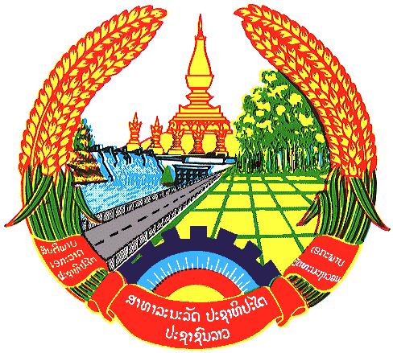
Statement by the delegation of the Lao PDR
At the 27th Session of UPR Working Group
Geneva, 1-12 May 2016
----------------

Review of Morocco, 2 May 2019 at 14:30-16:00 hours

Mr. President,

The Lao PDR warmly welcomes the delegation of the Kingdom of Morocco and would like to thank for their comprehensive presentation of National Report.

The Lao PDR is pleased to note efforts made by the Government of Morocco to further enhance human rights in the country on embarked major reform of its justice system by amended or adopted number of national laws and regulations related to human rights in order to create favorable condition for people to exercise their fundamental rights and freedom.

We commend measures undertaken by the Government of Morocco to improve the social protection system by extending social and medical coverage to various categories of populations, particularly we welcome the introduction of basic medical cover for students and the extension the range of services under compulsory health insurance system to the provision of dental care for active employee and retired person in the private sector.

My delegation take note with appreciation that the Government of Morocco has made progress in promoting child protection, empowerment of women and gender equality by integration of gender equality into public policies and in addressing poverty reduction.

In this regard, Lao PDR wishes to offer followings recommendations for consideration:

- To continue efforts to ensure vulnerable children and adolescents in rural communities access to quality education and health care services.
- To continue promote gender equality and involvement of women in politics and public services

We wish Morocco every success in its Third Cycle of UPR.

I thank you.

